|  |  |  |  |  |
| --- | --- | --- | --- | --- |
|  |  | | |  |
|  |  | | |  |
|  | Function Group Spec  Profile Settings Server - FnG  <<Logical>> (Allocated) | | |  |
|  |  |
|  |  |
|  |  | | |  |
| Document Type | **Function Specification** | | |  |
| Template Version | **6.0** | | |  |
| SysML Report Template Version | **O Beta (11/6/2019)** | | |  |
| Document ID | **functionspec_sysmlreporttemplate** | | |  |
| Document Location |  | | |  |
| Document Owner | **Justin Bauer, Walter Stephens** | | |  |
| Document Revision | **FGS0** | | |  |
| Document Status | **Draft** | | |  |
| Date Issued | **2021-02-15** | | |  |
| Date Revised | **2021-02-15** | | |  |
| Document Classification | GIS1 Item Number: | **27.60/35** | |  |
| GIS2 Classification: | **Confidential** | |
|  | | | | |
|  | | | | |
| Document Approval | | | | |
| Name | Role | | Email Confirmation | Date |
|  |  | |  |  |
|  |  | |  |  |

Auto-Generated by MagicDraw

Printed Copies are Uncontrolled

# Disclaimer

**This document contains Ford Motor Company Confidential information. Disclosure of the information contained in any portion of this document is not permitted without the expressed, written consent of a duly authorized representative of Ford Motor Company, Dearborn, Michigan, U.S.A.**

**Copyright, Ó 2016 Ford Motor Company**

This document contains information developed and accumulated by and for FORD MOTOR COMPANY. As such, it is a proprietary document, which, if disseminated to unauthorized persons, would provide others with restricted information, data, or procedures not otherwise available, exposing the FORD MOTOR COMPANY to potential harm.

Employees and suppliers having custody of this specification or authorized to use it must be cognizant of its proprietary nature and ensure that the information herein is not made available to unauthorized persons.

FORD MOTOR COMPANY reserves the right to protect this work as an unpublished copyrighted work in the event of an inadvertent or deliberate unauthorized publication. FORD MOTOR COMPANY also reserves its rights under copyright laws to protect this work as a published work.

This document or portions thereof shall not be distributed outside FORD MOTOR COMPANY without prior written consent. Refer all questions concerning disclosure to the author(s) or to any duly authorized representative of Ford Motor Company.

# Contents

1.1.1 Decomposition of 4

Disclaimer 16

Contents 17

2 Introduction 19

2.1 Document Purpose 19

2.2 Document Scope 19

2.3 Document Audience 19

2.3.1 Stakeholder List 19

2.4 Document Organization 19

2.4.1 Document Context 19

2.4.2 Document Structure 19

2.5 Document Conventions 20

2.5.1 Requirements Templates 20

3 Function Group Description 21

4 Functional Architecture 22

4.1 Description 22

4.2 Function List 22

4.3 Signal List 22

5 Function Specifications 23

5.1  23

5.1.1 Function Overview 23

5.1.2 Function Scope 25

5.1.3 Function Interfaces 26

5.1.4 Function Modeling 28

5.1.5 Function Requirements 28

6 Open Concerns 32

7 Revision History 33

8 Appendix 34

8.1 Data Dictionary 34

8.1.1 Logical Signals 34

8.1.2 Logical Parameters 34

8.1.3 Encoding Types 34

8.2 Glossary 34

8.2.1 Definitions 34

8.2.2 Abbreviations 35

**List of Figures**

Figure 1 Activity diagram “” depicting black box behavior collaboration 22

Figure 2: Activity Diagram of “” calling “” 26

Figure 3: 28

**List of Tables**

Table 1: - Decomposition Table 5

Table 2: Functions described in this specification 19

Table 3: List of Logical Functions 22

Table 4: Ford internal Documents 25

Table 5: Ford internal Documents *(not specified in model)* 25

Table 6: External documents and publications 25

Table 7: External documents and publications *(not specified in model)* 25

Table 8: Open Concerns *(Not supported by MagicDraw report generation.)* 32

Table 9: Definitions used in this document 35

Table 10: Abbreviations used in this document 35

# Introduction

## Document Purpose

The Function (Group) Specification (FS) specifies an individual function / a group of functions.

To get more information about the concept of feature, function and component level abstraction refer to the [Ford RE Wiki](http://wiki.ford.com/display/RequirementsEngineering/Requirements+Engineering+for+SW+Enabled+Features).

## Document Scope

The following set of functions from the [Global Feature & Function List](https://www.vsemweb.ford.com:443/tc/launchapp?-attach=true&-s=226TCSession&-o=ZmZNi0JHx3NrTDAAAAAAAAAAAAA) is described in this specification.

|  |  |  |  |
| --- | --- | --- | --- |
| **Function ID** | **Function Name** | **Owner** | **Reference** |
| Fn012421 | Send All Profile Settings |  |  |
| Fn012438 | Send Changed Profile Setting |  |  |
| Fn012467 | Execute Profile Settings |  |  |

**Table 2: Functions described in this specification**

## Document Audience

The FS is authored by the owners of the individual functions. All Stakeholders, i.e., all people who have a valid interest in the functions and their behavior should read and, if possible, review the FS. It needs to be guaranteed, that all stakeholders have access to the currently valid version of the FS.

**#Hint:** The FS template has the IP Classification “Proprietary” by default. IP Classification “Confidential” might be required in some cases, e.g. by Ford Functional Safety.

### Stakeholder List

For the latest list of the feature stakeholder and their roles & responsibilities refer to [PPP Stakeholder List](https://www.vsemweb.ford.com/tc/launchapp?-attach=true&-s=226TCSession&-o=S5U9Hrgbx3NrTDAAAAAAAAAAAAA&servername=Production_Server)

**#Hint:** Refer to [Ford RE Wiki – Stakeholder List](http://wiki.ford.com/display/RequirementsEngineering/Stakeholder+Analysis) on how to create a stakeholder list. The stakeholder list should be stored in VSEM in the pseudo folder “General Data Artifacts” of the corresponding function.

## Document Organization

### Document Context

Refer to the [Specification Structure page](http://wiki.ford.com/display/RequirementsEngineering/Specification+templates) in the [Ford RE Wiki](http://wiki.ford.com/display/RequirementsEngineering/Requirements+Engineering+for+SW+Enabled+Features) to understand how the FS relates to other Ford Requirements Documents and Specifications.

### Document Structure

The structure of this document is explained below:

**Section 1** – Introduction how to use this document including responsibilities and requisite documents. Explains the terminology. Gives a clarification of the definitions, concepts and abbreviations used in the document.

**Section 2** – Function Group Description. Gives an overview and the purpose of the function group.

**Section 3** – Functional Architecture: Specifies the overall functional architecture of the function group

**Section 4** – Function Specifications: Specifies the logical functions of the function group in detail

**Section 5** – List of Open Concerns

**Section 6** Revision history including a list of new or modified requirements. The requirements in this document are tagged, and this section contains different types of tables listing all, new, or changed requirements by their title and page no.

**Section 7** – Appendix: Presenting additional data mainly in a tabular form, e.g., a data dictionary

**#Hint:** All sections are mandatory, unless explicitly marked by the tag “#Classification” as “optional” or as applicable e.g. to certain domains like “Functional Safety”.

## Document Conventions

### Requirements Templates

Each requirement, use case or scenario in this specification shall follow the corresponding template given in the document template *Specification_Macros.dotm* at [RE Wiki - Specification Templates](http://wiki.ford.com/display/RequirementsEngineering/Specification+templates?src=contextnavpagetreemode).

#### Identification of Requirements

#### Requirements Attributes

The templates provided by *Specification_Macros.dotm* define a list of attributes for each requirement. This helps to classify the requirement. The attributes are explained at [RE Wiki - Requirements Attributes](http://wiki.ford.com/display/RequirementsEngineering/Requirements+Attributes?src=contextnavpagetreemode).

# Function Group Description

**#Classification:** Function Group only (remove section, if only a single Function is specified in this document)

**#Hint**: Provide an overview / a description of the Function Group

This Function Group consists of all functions allocated to 1052860247.jpg **Profile Settings Server - FnG** <<Logical>> including all functions in their corresponding call trees.

Description of Profile Settings Server - FnG:

The Profile Setting Server logical block is a generic term for any vehicle module that owns the execution and storage of profile settings. The scope of the logical block is how each module interacts with the Profile System, and not with the customer. This specification describes the general design each Profile Setting Server must follow to enable Personal and Portable Profiles.

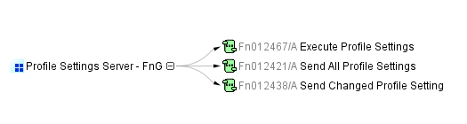

# Functional Architecture

**#Classification:** Function Group only (remove section, if only a single Function is specified in this document)

**#Hint:** The Functional Architecture shall reflect the result of the functional decomposition for a given feature or parts of it.

Refer to the [*RE Wiki – Functional Decomposition*](http://wiki.ford.com/display/RequirementsEngineering/Functional+Analysis+and+Architecture) for some guidance on how to decompose a feature into functions, i.e., how to find the right functional partitioning for the function level. The functions shown here are those, which are specified in section 5 “Function Specifications”.

## Description

**#Hint:** Provide some informal description of the characteristics of the chosen architecture. Also give some graphical representation of the Functional Architecture. Either SysML Internal Block diagrams or [Data Flow Diagrams](http://wiki.ford.com/display/RequirementsEngineering/Data+Flow+Diagram?src=contextnavpagetreemode) could be used to depict such a Functional Architecture.

**#Link:** [*SysML – Internal Block Diagrams*](https://pd3.spt.ford.com/sites/SystemsEngineering/SEC/sysml-teamsite/SysML%20Wiki/Internal%20Block%20Diagram%20Basics.aspx) or [*RE Wiki - Data Flow Diagrams*](http://wiki.ford.com/display/RequirementsEngineering/Data+Flow+Diagram?src=contextnavpagetreemodehttp://wiki.ford.com/display/RequirementsEngineering/Data+Flow+Diagram?src=contextnavpagetreemode)

## Function List

|  |  |  |  |
| --- | --- | --- | --- |
| **Function ID** | **Function Name** | **Function Description** | **ASIL** |
| Fn012421/A | -1231279064.jpg Send All Profile Settings <<Subsystem Function>> | This function sends all profile data stored on the Profile Setting Server to the Profile Management Server when the QueryProfile_Rq is received. This function is mainly used during initial profile creation in the vehicle. |  |
| Fn012438/A | -1231279064.jpg Send Changed Profile Setting <<Subsystem Function>> | A function of the Profile Setting Servers that sends changed profile settings Feature ID and new Feature Value to the Profile Management Server when the customer makes a change. |  |
| Fn012467/A | -1231279064.jpg Execute Profile Settings <<Subsystem Function>> | This is a function of the Profile Setting Servers with the purpose of receiving and applying profile settings that are sent by the Profile Management Server. This function executes profile settings using Feature ID, Feature Value and Pers Index as inputs. |  |

Table 3: List of Logical Functions

## Signal List

Refer to the Data Dictionary - Logical Signals.

# Function Specifications

## -1231279064.jpg Execute Profile Settings

### Function Overview

#### Description

**#Hint:** Some descriptive text to explain the purpose and functionality of the function.

Function is allocated to:

* 1052860247.jpg Profile Settings Server - FnG <<Logical>>

This is a function of the Profile Setting Servers with the purpose of receiving and applying profile settings that are sent by the Profile Management Server. This function executes profile settings using Feature ID, Feature Value and Pers Index as inputs.

#### Variants

**#Classification**: Mandatory (State “Not applicable”, if not used)

**#Hint:** If different variants of the same function are specified in this section, list those variants in the table below.

Variants on Function level could be driven technology or feature content. Example: There could be a “Low Content” and a “High Content” variant of some exterior lighting function. The Low Content variant applies for Conventional Headlight technology, the High Content variant applies for LED and Xenon technology. In this case we call the different technologies the Variant Options (for the time being you could think of them as Logical Parameters) which the Variant depends on. The optional column “Variant condition” allows to express the dependency of a Variant based on Variant Options/Logical Parameters.

If requirements/signals are not applicable for all variants/variant options, those requirements should state explicitly, which function variant/variant option they apply to.

**#Link:** [RE Wiki – Variant Management](http://wiki.ford.com/display/RequirementsEngineering/Variant+Management).

*Not supported by MagicDraw report generation.*

#### Input Requirements

**#Classification**: Mandatory (State “Not applicable”, if not used)

**#Hint:** List any input requirements here (legal, Trustmark), which need to be taken into account, beyond what is specified in the corresponding Feature Documents.

*Not supported by MagicDraw report generation.*

#### Assumptions

**#Classification**: Mandatory (State “Not applicable”, if not used)

**#Hint:** A list of known assumptions concerning the effects of the function’s behavior on other functions or elements (i.e., dependencies) as well as assumptions on the behavior expected by the function (e.g. known limitations). During the course of the development most of those assumptions are typically either converted into actual requirements or discarded at some point – such that this chapter remains mostly empty.

No assumptions specified for this function.

#### References

##### Ford Documents

List here all Ford internal documents, which are directly related to the feature.

| **Reference** | **Title** | **Doc. ID** | **Revision** |
| --- | --- | --- | --- |
|  | Enhanced Memory Feature Specification | VDOC041625 | V3.1 |

Table 5: Ford internal Documents *(not specified in model)*

##### External Documents and Publications

The list of external documents could include books, reports and online sources.

**#Hint:** You may refer to [IEEE Citation Reference](http://www.ieee.org/documents/ieeecitationref.pdf) on how to format a reference.

| **Reference** | **Document / Publication** |
| --- | --- |
|  |  |

Table 7: External documents and publications *(not specified in model)*

#### Glossary

See Appendix for Definitions and Abbreviations.

### Function Scope

The -1231279064.jpg **– “Execute Profile Settings”** function is called by the following functions:

* 168958035.jpg – “1 Link New Vehicle Profile w/ FP Account”
* 168958035.jpg – “2 Link Pre-existing Vehicle Profile w/ FP account”
* 168958035.jpg – “9 Recall Profile and ID User”
* 168958035.jpg – “14 Send Profile to vehicle from Off-Board Interface”
* 168958035.jpg – “16 Restore Changed Profile”

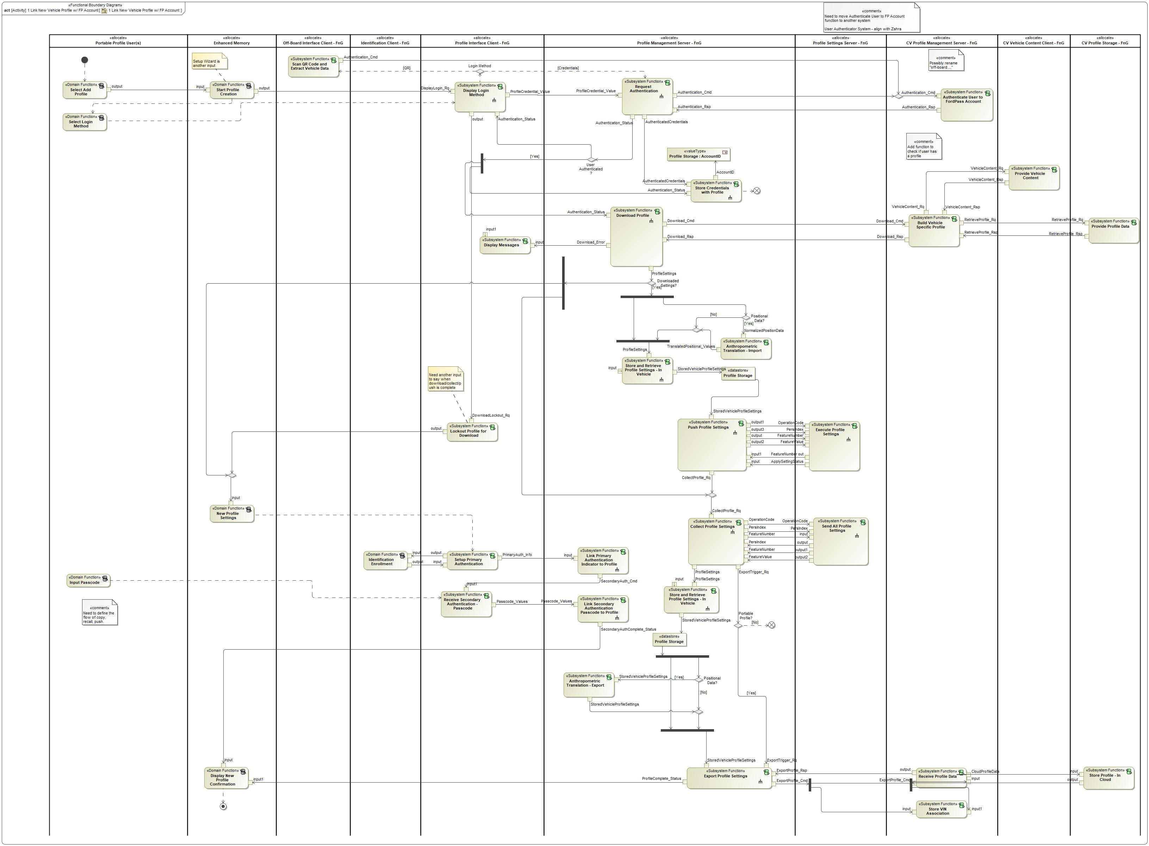

Figure : Activity Diagram of 168958035.jpg “1 Link New Vehicle Profile w/ FP Account” calling -1231279064.jpg “Execute Profile Settings”

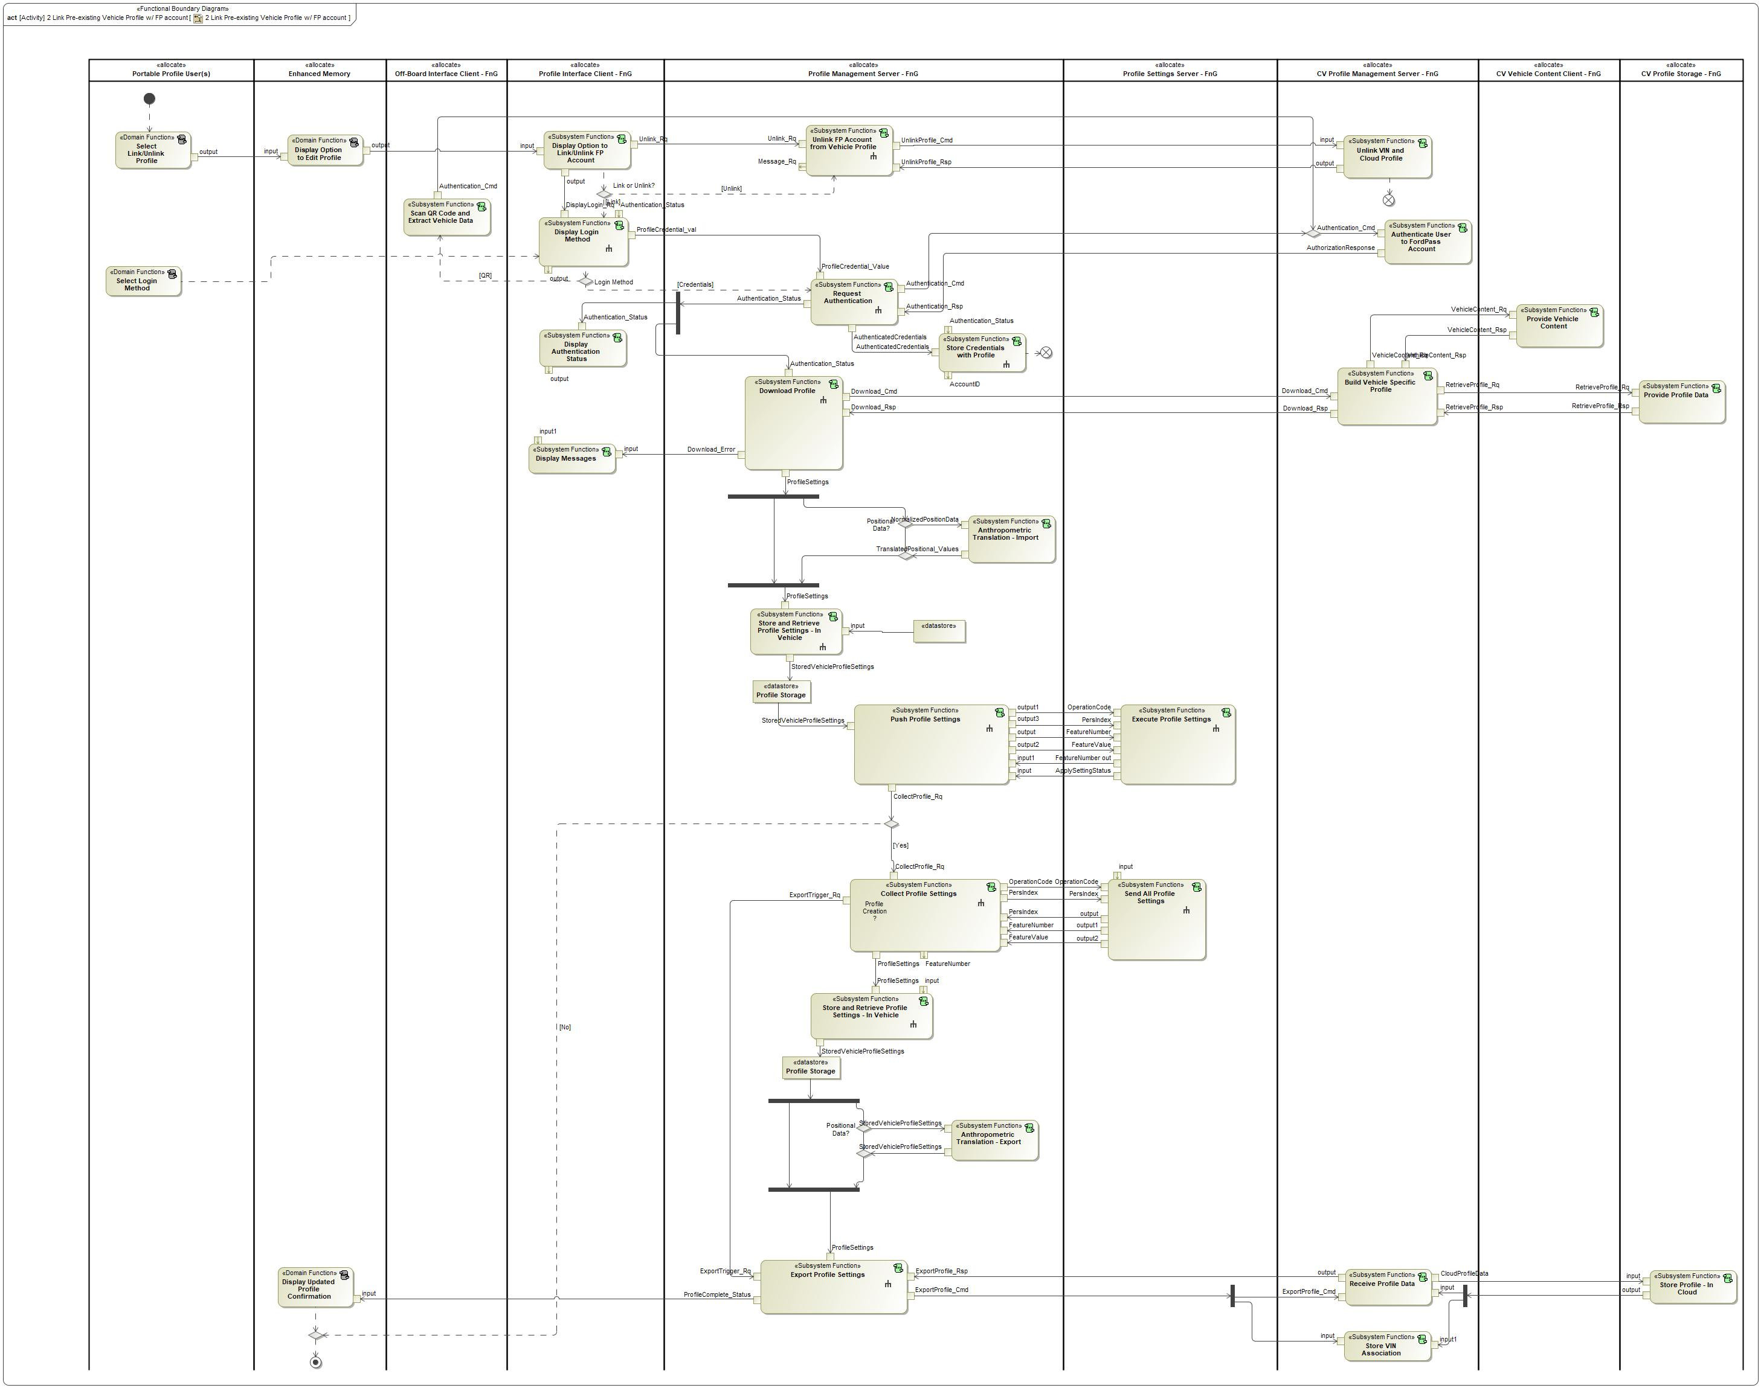

Figure : Activity Diagram of 168958035.jpg “2 Link Pre-existing Vehicle Profile w/ FP account” calling -1231279064.jpg “Execute Profile Settings”

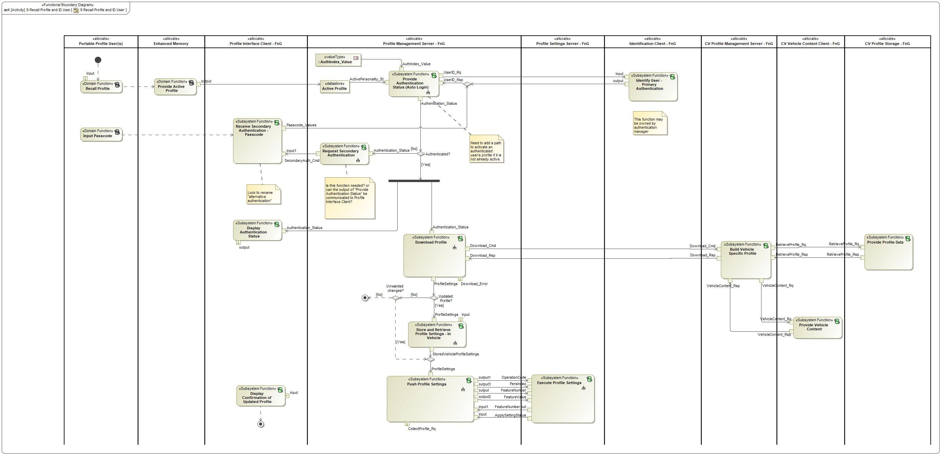

Figure : Activity Diagram of 168958035.jpg “9 Recall Profile and ID User” calling 1201103667.jpg “Execute Profile Settings”

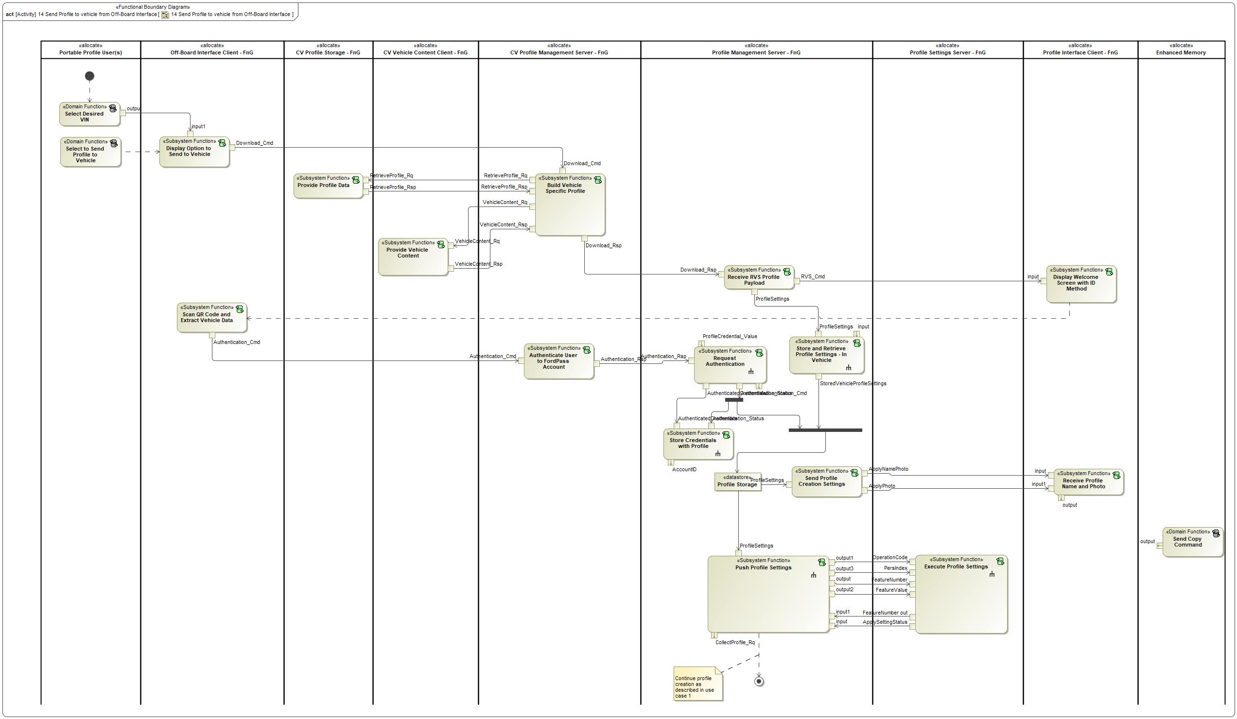

Figure : Activity Diagram of 168958035.jpg “14 Send Profile to vehicle from Off-Board Interface” calling 1201103667.jpg “Execute Profile Settings”

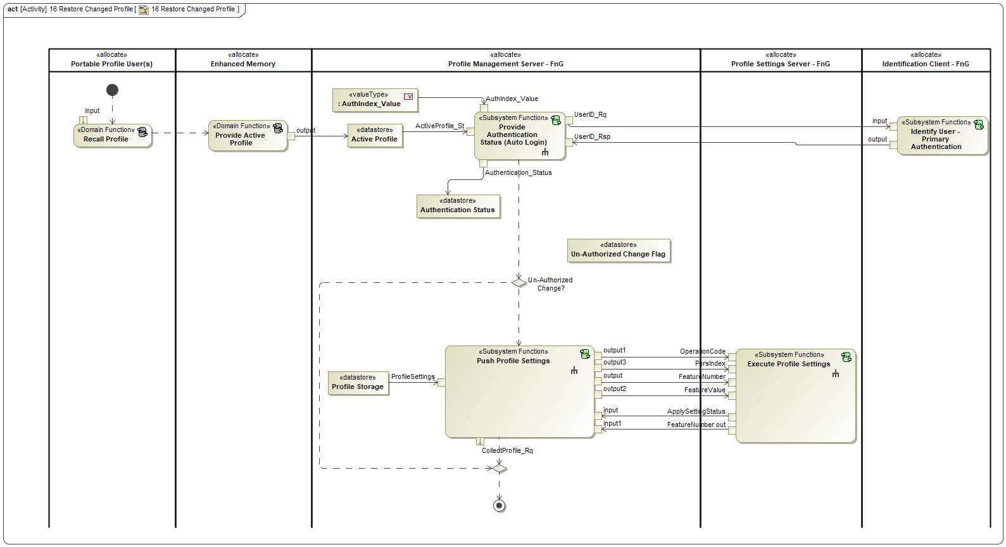

Figure : Activity Diagram of 168958035.jpg “16 Restore Changed Profile” calling 1201103667.jpg “Execute Profile Settings”

### Function Interfaces

**#Link:** [RE Wiki – Adding a Logical Signal or Parameter](http://wiki.ford.com/display/RequirementsEngineering/Adding+a+Logical+Signal+or+Parameter)

#### Logical Inputs

|  |  |
| --- | --- |
| **Signal Name** | **Description** |
| FeatureNumber  Type:  1645473355.jpg FeatureNumber | Signal Description:  Signal that carries the hexadecimal values assigned to each setting that is stored in the profile.  Received from:   * 1201103667.jpg Push Profile Settings |
| OperationCode  Type:  1645473355.jpg OperationCode | Signal Description:  Determines which operation the Profile Setting Server is requested to execute. Depending on the operation code, the following signals could contain more or less data.  Received from:   * 1201103667.jpg Push Profile Settings |
| PersIndex  Type:  1645473355.jpg PersIndex | Signal Description:  Determines the profile number that the Profile Setting Server needs to execute an operation on.  Received from:   * 1201103667.jpg Push Profile Settings |
| FeatureValue  Type:  1645473355.jpg FeatureValue | Signal Description:  Carries the setting configuration for a Feature Number. Feature Numbers and Feature Values are always paired together.  Received from:   * 1201103667.jpg Push Profile Settings |

#### Logical Outputs

|  |  |
| --- | --- |
| **Signal Name** | **Description** |
| ApplySettingStatus  Type:  1645473355.jpg ApplySettingStatus | Signal Description:  Determines if a profile setting had successfully been set by the Profile Setting Server.  Sent to:   * 1201103667.jpg Push Profile Settings |
| FeatureNumber out  Type:  1645473355.jpg FeatureNumber | Signal Description:  Signal that carries the hexadecimal values assigned to each setting that is stored in the profile.  Sent to:   * 1201103667.jpg Push Profile Settings |

#### Logical Parameters

**#Hint**: Put requirements for parameters here, which are implemented as configuration parameters using Method 2 or 3 or as parameters for calibration.

*Not supported by MagicDraw report generation.*

### Function Modeling

**#Classification:** Mandatory

**#Hint:** Typical modeling artifacts in this section are State Machines, Activity Diagrams / Flow Charts, Decision Tables, and possibly Sequence Diagrams, which can all be used as techniques to analyze the function requirements.

**#Links:** Analyze / Model Requirements: [RE Wiki – Analyze / Model Requirements](http://wiki.ford.com/pages/viewpage.action?pageId=110594919&src=contextnavpagetreemode)

#### Use Cases

**#Classification:** Infotainment Only (remove section, if not used)

**#Hint:** Some Domains (e.g. Infotainment) use not only Customer Use Cases (in the Feature Doc), but refine Use Case descriptions down to function level. In general, the RE approach encourages the use of Use Cases on Feature Level but not on Function Level. Activity Diagrams are a more suitable way to express the same on Function Level.

**#Links:** Infotainment – “Harmony Systems Engineering” Approach

*Not supported by MagicDraw report generation.*

#### State Charts / Activity Diagrams / Sequence Diagrams / Decision Tables

**#Classification:** Mandatory

**#Hint:** It is highly recommended to use at least one of the following modeling techniques for modeling and analyzing the Function behavior and derived requirements (refer to sample diagrams below):

State Machines, Activity Diagrams / Flow Charts, or Decision Tables

Optionally, Sequence Diagrams might help to analyze the interaction between Functions.

**#Links:** Analyze / Model Requirements: [RE Wiki – Analyze / Model Requirements](http://wiki.ford.com/pages/viewpage.action?pageId=110594919&src=contextnavpagetreemode)

State Charts [RE Wiki – State Charts](http://wiki.ford.com/display/RequirementsEngineering/State+Charts?src=contextnavpagetreemode)

Activity Diagrams: [RE Wiki – Activity Diagram](http://wiki.ford.com/display/RequirementsEngineering/Activity+Diagram?src=contextnavpagetreemode), [SysML User Group – Activity Diagram Basics](https://pd3.spt.ford.com/sites/SystemsEngineering/SEC/sysml-teamsite/SysML%20Wiki/Activity%20Diagram%20Basics.aspx)

Sequence Diagrams: [RE Wiki – Sequence Chart](http://wiki.ford.com/display/RequirementsEngineering/Sequence+Chart?src=contextnavpagetreemode), [SysML User Group – Sequence Diagram Basics](https://pd3.spt.ford.com/sites/SystemsEngineering/SEC/sysml-teamsite/SysML%20Wiki/Sequence%20Diagram%20Basics.aspx)

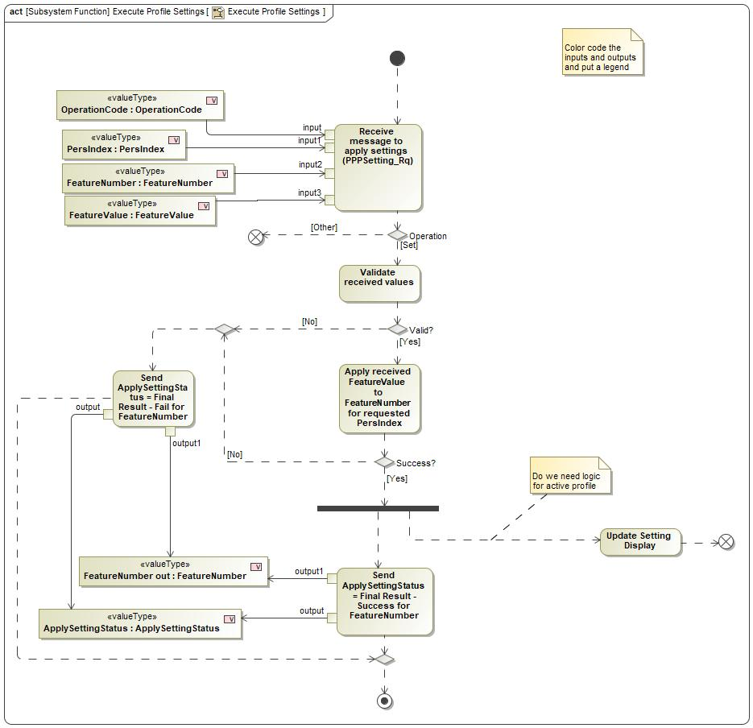

Figure : Execute Profile Settings

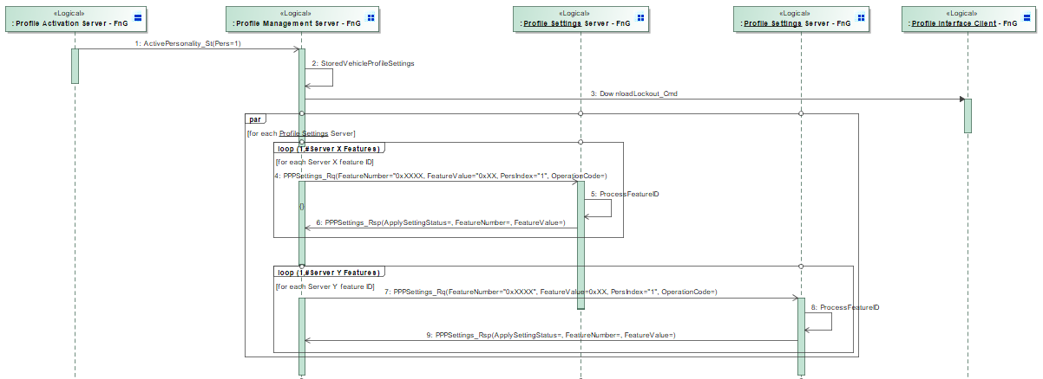

Figure : Execute Profile Settings Sequence Diagram

### Function Requirements

#Link: [*RE Wiki – How to write good requirements*](http://wiki.ford.com/display/RequirementsEngineering/How+to+write+better+requirements?src=contextnavpagetreemode)

#### Functional Requirements

***#Hint:*** *Please also consider specific situations like Initialization (Startup) and Deinitialization (Shutdown) apart from Normal Operation and Error Handling. E.g. a* state chart or activity diagram might help for better understanding.

##### Normal Operation

PPPSettings_Rsp Message Parameters

When the Profile Setting Server is responding to a set operation from the Profile Management Server, the following signals shall be packaged into one signal to create the response message:

- FeatureNumber

- ApplySettingStatus

*Note: Signal definitions can be found in the data dictionary at bottom of specification

|  |  |  |  |  |  |  |  |
| --- | --- | --- | --- | --- | --- | --- | --- |
| Requirement ID: | | | | | | | |
| **Rationale** | The ApplySettingStatus is specific for each Feature Number, so the two signals must be paired together. | | | | | | |
| **Acceptance Criteria** |  | | | | | | |
| **Notes** |  | | | | | | |
| **Source** |  | | | | | **Owner** |  |
| **Source Req.** |  | | | | | **V&V Method** |  |
| **Type** |  | | | **Priority** |  | **Status** |  |
| [Req. Template](http://wiki.ford.com/display/RequirementsEngineering/Requirements+Attributes) Version | | 6.0 | End of Requirement | | | | |

REQ-352214/A Receiving and Processing PPPSettings_Rq

When a Profile Setting Server receives the PPPSettings_Rq message from the Profile Management Server that contains a OperationCode = Set, PersIndex, FeatureNumber and FeatureValue, the Profile Setting Server shall apply the Feature Value to the Feature Number for the requested Pers Index once the signal parameters are validated.

The requested Pers Index does not need to be the active profile to receive and apply the profile settings.

|  |  |  |  |  |  |  |  |
| --- | --- | --- | --- | --- | --- | --- | --- |
| Requirement ID: REQ-352214/A | | | | | | | |
| **Rationale** | PPP requires a central profile storage in the Profile Management Server, thus requiring a means to apply settings from the central storage to each Profile Setting Server. | | | | | | |
| **Acceptance Criteria** |  | | | | | | |
| **Notes** |  | | | | | | |
| **Source** |  | | | | | **Owner** |  |
| **Source Req.** |  | | | | | **V&V Method** |  |
| **Type** |  | | | **Priority** |  | **Status** |  |
| [Req. Template](http://wiki.ford.com/display/RequirementsEngineering/Requirements+Attributes) Version | | 6.0 | End of Requirement | | | | |

REQ-352219/A Profile Setting Servers remember valid Feature Number

Profile Setting Servers shall only apply Feature Value for Feature Numbers supported by the settings server.

|  |  |  |  |  |  |  |  |
| --- | --- | --- | --- | --- | --- | --- | --- |
| Requirement ID: REQ-352219/A | | | | | | | |
| **Rationale** | Do not want the Profile Setting Server to apply a Value for an incorrect Feature ID. | | | | | | |
| **Acceptance Criteria** |  | | | | | | |
| **Notes** |  | | | | | | |
| **Source** |  | | | | | **Owner** |  |
| **Source Req.** |  | | | | | **V&V Method** |  |
| **Type** |  | | | **Priority** |  | **Status** |  |
| [Req. Template](http://wiki.ford.com/display/RequirementsEngineering/Requirements+Attributes) Version | | 6.0 | End of Requirement | | | | |

REQ-405855/A PPPSettings_Rq Message Parameters

When profile settings are being pushed from the Profile Management Server to the Profile Setting Servers, the following signals shall all be packaged into a single message:

- OperationCode

- PersIndex

- FeatureNumber

- FeatureValue

*Note: Signal definitions can be found in the data dictionary at bottom of specification.

|  |  |  |  |  |  |  |  |
| --- | --- | --- | --- | --- | --- | --- | --- |
| Requirement ID: REQ-405855/A | | | | | | | |
| **Rationale** | FeatureNumber and FeatureValue signals must be paired together in an array so the profile setting server can apply the correct feature value to the feature number. | | | | | | |
| **Acceptance Criteria** |  | | | | | | |
| **Notes** |  | | | | | | |
| **Source** |  | | | | | **Owner** |  |
| **Source Req.** |  | | | | | **V&V Method** |  |
| **Type** |  | | | **Priority** |  | **Status** |  |
| [Req. Template](http://wiki.ford.com/display/RequirementsEngineering/Requirements+Attributes) Version | | 6.0 | End of Requirement | | | | |

REQ-405856/A Conditions to receive Profile Settings

Each Profile Setting Server shall be capable of receiving profile settings when the following conditions are met:

- Ignition Status = Run

- Gear Position = Park (for automatic transmission)

- Vehicle Speed <= Driver Restriction Threshold

If any of the following conditions are not true, the Profile Setting Server shall individually determine if they are able to apply profile settings.

|  |  |  |  |  |  |  |  |
| --- | --- | --- | --- | --- | --- | --- | --- |
| Requirement ID: REQ-405856/A | | | | | | | |
| **Rationale** | Each setting server may have its own pre-conditions to apply settings. Profile Management Server can still send settings, but Profile Setting Server may not receive. | | | | | | |
| **Acceptance Criteria** |  | | | | | | |
| **Notes** |  | | | | | | |
| **Source** |  | | | | | **Owner** |  |
| **Source Req.** |  | | | | | **V&V Method** |  |
| **Type** |  | | | **Priority** |  | **Status** |  |
| [Req. Template](http://wiki.ford.com/display/RequirementsEngineering/Requirements+Attributes) Version | | 6.0 | End of Requirement | | | | |

REQ-405857/A Display active profile settings after being applied

After a profile setting has been sent by the Profile Management Server and applied by the Profile Setting Server, the Profile Setting Server shall update their own HMI client to display the changed setting.

|  |  |  |  |  |  |  |  |
| --- | --- | --- | --- | --- | --- | --- | --- |
| Requirement ID: REQ-405857/A | | | | | | | |
| **Rationale** | PPP does not own HMI for all profile settings. | | | | | | |
| **Acceptance Criteria** |  | | | | | | |
| **Notes** |  | | | | | | |
| **Source** |  | | | | | **Owner** |  |
| **Source Req.** |  | | | | | **V&V Method** |  |
| **Type** |  | | | **Priority** |  | **Status** |  |
| [Req. Template](http://wiki.ford.com/display/RequirementsEngineering/Requirements+Attributes) Version | | 6.0 | End of Requirement | | | | |

REQ-405859/A Memory capability

Each Profile Setting Server shall support enough memory to support at least 5 profile memory positions:

1. Profile 1

2. Profile 2

3. Profile 3

4. Profile 4 (transitional)

5. Vehicle/Guest

|  |  |  |  |  |  |  |  |
| --- | --- | --- | --- | --- | --- | --- | --- |
| Requirement ID: REQ-405859/A | | | | | | | |
| **Rationale** | PPP allows for 3 locally saved profiles that can be recalled without needing to push data from the profile management server to the setting servers on every recall. The Profile 4 (transitional) is used to allow more than 3 profiles to be saved to the vehicle and recalled by pushing profile data for every recall. | | | | | | |
| **Acceptance Criteria** |  | | | | | | |
| **Notes** |  | | | | | | |
| **Source** |  | | | | | **Owner** |  |
| **Source Req.** |  | | | | | **V&V Method** |  |
| **Type** |  | | | **Priority** |  | **Status** |  |
| [Req. Template](http://wiki.ford.com/display/RequirementsEngineering/Requirements+Attributes) Version | | 6.0 | End of Requirement | | | | |

REQ-405860/A Transitional Memory Position

Each Profile Setting Server shall support a Profile 4 memory position for the purpose of a transitional profile.

**Note**

PPP allows for 10 profiles, but only 3 profiles are stored on the Profile Setting Server. The 4th profile position will be used to activate profiles 4-10. Each time one of these profiles are activated the settings will be applied from Profile Management Server to the Profile Setting Servers.

|  |  |  |  |  |  |  |  |
| --- | --- | --- | --- | --- | --- | --- | --- |
| Requirement ID: REQ-405860/A | | | | | | | |
| **Rationale** |  | | | | | | |
| **Acceptance Criteria** |  | | | | | | |
| **Notes** |  | | | | | | |
| **Source** |  | | | | | **Owner** |  |
| **Source Req.** |  | | | | | **V&V Method** |  |
| **Type** |  | | | **Priority** |  | **Status** |  |
| [Req. Template](http://wiki.ford.com/display/RequirementsEngineering/Requirements+Attributes) Version | | 6.0 | End of Requirement | | | | |

REQ-405862/A Validate PPPSettings_Rq

When a Profile Setting Server receives the PPPSettings_Rq, the Profile Setting Server shall validate that the received parameters are within a valid range identified by the Profile Attribute Specification.

See reference documents for link to Profile Attribute Specification.

|  |  |  |  |  |  |  |  |
| --- | --- | --- | --- | --- | --- | --- | --- |
| Requirement ID: REQ-405862/A | | | | | | | |
| **Rationale** |  | | | | | | |
| **Acceptance Criteria** |  | | | | | | |
| **Notes** |  | | | | | | |
| **Source** |  | | | | | **Owner** |  |
| **Source Req.** |  | | | | | **V&V Method** |  |
| **Type** |  | | | **Priority** |  | **Status** |  |
| [Req. Template](http://wiki.ford.com/display/RequirementsEngineering/Requirements+Attributes) Version | | 6.0 | End of Requirement | | | | |

REQ-405864/A Sending a Successful PPPSettings_Rsp

The Profile Setting Server shall send the PPPSettings_Rsp with a status of Final Result - Success when the Profile Setting Server is able to apply the parameters received in the request, PPPSettings_Rq.

|  |  |  |  |  |  |  |  |
| --- | --- | --- | --- | --- | --- | --- | --- |
| Requirement ID: REQ-405864/A | | | | | | | |
| **Rationale** | Profile Management Server knows not to attempt a retry. | | | | | | |
| **Acceptance Criteria** |  | | | | | | |
| **Notes** |  | | | | | | |
| **Source** |  | | | | | **Owner** |  |
| **Source Req.** |  | | | | | **V&V Method** |  |
| **Type** |  | | | **Priority** |  | **Status** |  |
| [Req. Template](http://wiki.ford.com/display/RequirementsEngineering/Requirements+Attributes) Version | | 6.0 | End of Requirement | | | | |

##### Error Handling

***#Hint:*** *FMEA counter measures could be considered as requirements in this chapter*

REQ-353147/A Setting Server Unable to Apply Setting

If a Profile Setting Server is unable to apply a Feature Value for a Feature Number that is sent from the Profile Management Server, the Profile Setting Server shall retain the previous Feature Value for the requested Feature Number and send a PPPSettings_Rsp with ApplySettingStatus = Final Result - Fail and the FeatureNumber that failed.

|  |  |  |  |  |  |  |  |
| --- | --- | --- | --- | --- | --- | --- | --- |
| Requirement ID: REQ-353147/A | | | | | | | |
| **Rationale** | Do not want to change to a default setting, but would rather the user decide the setting preference. | | | | | | |
| **Acceptance Criteria** |  | | | | | | |
| **Notes** |  | | | | | | |
| **Source** |  | | | | | **Owner** |  |
| **Source Req.** |  | | | | | **V&V Method** |  |
| **Type** |  | | | **Priority** |  | **Status** |  |
| [Req. Template](http://wiki.ford.com/display/RequirementsEngineering/Requirements+Attributes) Version | | 6.0 | End of Requirement | | | | |

REQ-405858/A Priority of applying profile settings

If a Profile Setting Server receives a request to change a profile setting from the PPPSettings_Rq signal and the setting's HMI Client simultaneously, the Profile Setting Server shall retain the setting value received from HMI Client.

|  |  |  |  |  |  |  |  |
| --- | --- | --- | --- | --- | --- | --- | --- |
| Requirement ID: REQ-405858/A | | | | | | | |
| **Rationale** | Priority should be given to the customer actions. | | | | | | |
| **Acceptance Criteria** |  | | | | | | |
| **Notes** |  | | | | | | |
| **Source** |  | | | | | **Owner** |  |
| **Source Req.** |  | | | | | **V&V Method** |  |
| **Type** |  | | | **Priority** |  | **Status** |  |
| [Req. Template](http://wiki.ford.com/display/RequirementsEngineering/Requirements+Attributes) Version | | 6.0 | End of Requirement | | | | |

REQ-405863/A PPPSettings_Rq parameters are out of range

If a Profile Setting Server receives an PPPSettings_Rq that is determined to be invalid, the Profile Setting Server shall send a PPPSettings_Rsp with a ApplySettingStatus = Final Result - Fail status and failed FeatureNumber.

|  |  |  |  |  |  |  |  |
| --- | --- | --- | --- | --- | --- | --- | --- |
| Requirement ID: REQ-405863/A | | | | | | | |
| **Rationale** |  | | | | | | |
| **Acceptance Criteria** |  | | | | | | |
| **Notes** |  | | | | | | |
| **Source** |  | | | | | **Owner** |  |
| **Source Req.** |  | | | | | **V&V Method** |  |
| **Type** |  | | | **Priority** |  | **Status** |  |
| [Req. Template](http://wiki.ford.com/display/RequirementsEngineering/Requirements+Attributes) Version | | 6.0 | End of Requirement | | | | |

#### Non-Functional Requirements

***#Hint:*** *Non-functional requirements specify some performance criteria in addition to the functional behavior given defined by the functional requirements. Timing (if not already included in the functional requirements), security details (e.g. how secure does an algorithm have to be) or reliability (e.g. mean time between failure) could be specified in this section.*

REQ-405861/A Execute Profile Settings Performance

The Profile Setting Servers shall be able to receive a PPPSettings_Rq, process and send a PPPSettings_Rsp within xx ms of receiving the PPPSettings_Rq.

|  |  |  |  |  |  |  |  |
| --- | --- | --- | --- | --- | --- | --- | --- |
| Requirement ID: REQ-405861/A | | | | | | | |
| **Rationale** |  | | | | | | |
| **Acceptance Criteria** |  | | | | | | |
| **Notes** |  | | | | | | |
| **Source** |  | | | | | **Owner** |  |
| **Source Req.** |  | | | | | **V&V Method** |  |
| **Type** |  | | | **Priority** |  | **Status** |  |
| [Req. Template](http://wiki.ford.com/display/RequirementsEngineering/Requirements+Attributes) Version | | 6.0 | End of Requirement | | | | |

#### Functional Safety Requirements

**#Classification**: Functional Safety only – If not used, remove content and state “Not Applicable”

***#Hint:*** *Add Functional Safety Requirements (FSRs) derived for this function.*

**#Link:** [Functional Safety Sharepoint](https://pd3.spt.ford.com/sites/GlobalFunctionalSafety/Pages/default.aspx) – Functional Safety Concept

[RE Wiki - Requirements Attributes](http://wiki.ford.com/display/RequirementsEngineering/Requirements+Attributes)

No Functional Safety Requirements specified.

##### ASIL Decomposition of Functional Safety Requirements

**#Classification**: Functional Safety only – If not used, remove content and state “Not Applicable”

***#Hint:*** *Sometimes an ASIL decomposition of Functional Safety Requirements is required. The decomposed FSRs should be listed beneath each ASIL Decomposition table below and referenced inside the table by ID and Title*

**#Link:** [Functional Safety Sharepoint](https://pd3.spt.ford.com/sites/GlobalFunctionalSafety/Pages/default.aspx) – Functional Safety Concept

No Functional Safety Requirements with ASIL Decompositions specified.

#### Other Requirements

##### Design Requirements

***#Hint:*** *Requirements of a Logical Function should be typically agnostic of their SW/HW implementation*. If for specific reasons the function owner needs to define explicitly design constraints, it can be done in this chapter.

No Design Requirements specified.

## 1201103667.jpg Send All Profile Settings

### Function Overview

#### Description

Function is allocated to:

* -214814297.jpg Profile Settings Server - FnG <<Logical>>

This function sends all profile data stored on the Profile Setting Server to the Profile Management Server when the QueryProfile_Rq is received. This function is mainly used during initial profile creation in the vehicle.

#### Variants

*Not supported by MagicDraw report generation.*

#### Input Requirements

*Not supported by MagicDraw report generation.*

#### Assumptions

No assumptions specified for this function.

#### References

##### Ford Documents

List here all Ford internal documents, which are directly related to the feature.

| **Reference** | **Title** | **Doc. ID** | **Revision** |
| --- | --- | --- | --- |
|  |  |  |  |

Table 5: Ford internal Documents *(not specified in model)*

##### External Documents and Publications

The list of external documents could include books, reports and online sources.

| **Reference** | **Document / Publication** |
| --- | --- |
|  |  |

Table 7: External documents and publications *(not specified in model)*

#### Glossary

See Appendix for Definitions and Abbreviations.

### Function Scope

The 1201103667.jpg **– “Send All Profile Settings”** function is called by the following functions:

* 168958035.jpg – “1 Link New Vehicle Profile w/ FP Account”
* 168958035.jpg – “2 Link Pre-existing Vehicle Profile w/ FP account”



Figure : Activity Diagram of 168958035.jpg “1 Link New Vehicle Profile w/ FP Account” calling 1201103667.jpg “Send All Profile Settings”



Figure : Activity Diagram of 168958035.jpg “2 Link Pre-existing Vehicle Profile w/ FP account” calling 1201103667.jpg “Send All Profile Settings”

### Function Interfaces

#### Logical Inputs

|  |  |
| --- | --- |
| **Signal Name** | **Description** |
| input  Type:  1645473355.jpg FeatureNumber | Signal Description:  Signal that carries the hexadecimal values assigned to each setting that is stored in the profile.  Received from:   * 1201103667.jpg Collect Profile Settings |
| OperationCode  Type:  1645473355.jpg OperationCode | Signal Description:  Determines which operation the Profile Setting Server is requested to execute. Depending on the operation code, the following signals could contain more or less data.  Received from:   * 1201103667.jpg Collect Profile Settings |
| PersIndex  Type:  1645473355.jpg PersIndex | Signal Description:  Determines the profile number that the Profile Setting Server needs to execute an operation on.  Received from:   * 1201103667.jpg Collect Profile Settings |

#### Logical Outputs

|  |  |
| --- | --- |
| **Signal Name** | **Description** |
| output1  Type:  1645473355.jpg FeatureNumber | Signal Description:  Signal that carries the hexadecimal values assigned to each setting that is stored in the profile.  Sent to:   * 1201103667.jpg Collect Profile Settings |
| output2  Type:  1645473355.jpg FeatureValue | Signal Description:  Carries the setting configuration for a Feature Number. Feature Numbers and Feature Values are always paired together.  Sent to:   * 1201103667.jpg Collect Profile Settings |
| output  Type:  1645473355.jpg PersIndex | Signal Description:  Determines the profile number that the Profile Setting Server needs to execute an operation on.  Sent to:   * 1201103667.jpg Collect Profile Settings |

#### Logical Parameters

*Not supported by MagicDraw report generation.*

### Function Modeling

#### Use Cases

*Not supported by MagicDraw report generation.*

#### State Charts / Activity Diagrams / Sequence Diagrams / Decision Tables

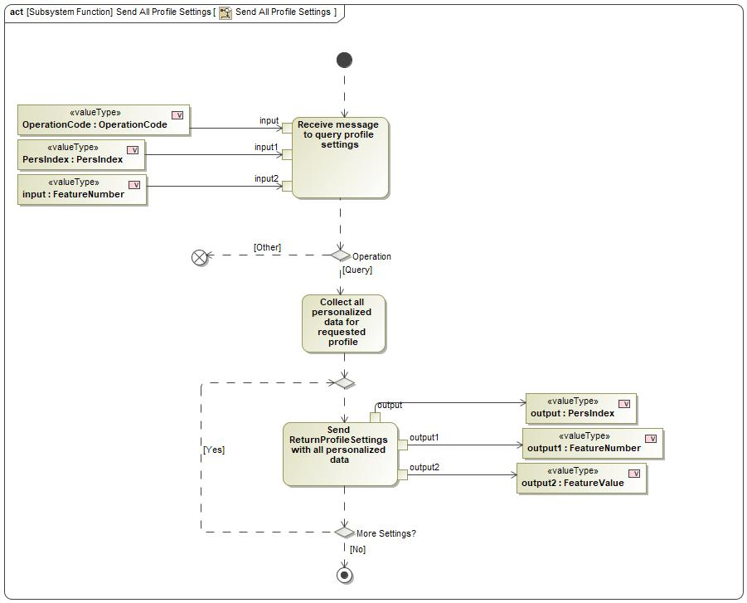

Figure : Send All Profile Settings

### Function Requirements

#### Functional Requirements

##### Normal Operation

REQ-352238/A Response to a Profile Management Server Query

When the Profile Setting Server receives the OperationCode = Query signal and PersIndex from the Profile Management Server, the Profile Setting Server shall send the ReturnProfileSetting message for each FeatureNumber and FeatureValue combination stored by the Profile Setting Server for the requested PersIndex.

|  |  |  |  |  |  |  |  |
| --- | --- | --- | --- | --- | --- | --- | --- |
| Requirement ID: REQ-352238/A | | | | | | | |
| **Rationale** | Profile Setting Server needs to respond for each possible Feature ID | | | | | | |
| **Acceptance Criteria** |  | | | | | | |
| **Notes** |  | | | | | | |
| **Source** |  | | | | | **Owner** |  |
| **Source Req.** |  | | | | | **V&V Method** |  |
| **Type** |  | | | **Priority** |  | **Status** |  |
| [Req. Template](http://wiki.ford.com/display/RequirementsEngineering/Requirements+Attributes) Version | | 6.0 | End of Requirement | | | | |

REQ-352239/A Powermode conditions to send ReturnProfileSetting to Profile Management Server

Each Profile Setting Server shall be capable of sending the ReturnProfileSetting message to the Profile Management server when the vehicle Ignition = RUN and the Profile Setting Server is fully powered.

Note: Individual profile setting servers may have additional pre-conditions that prevent sending the ReturnProfileSetting message.

|  |  |  |  |  |  |  |  |
| --- | --- | --- | --- | --- | --- | --- | --- |
| Requirement ID: REQ-352239/A | | | | | | | |
| **Rationale** | Each Profile Setting Server has different power mode conditions. | | | | | | |
| **Acceptance Criteria** |  | | | | | | |
| **Notes** |  | | | | | | |
| **Source** |  | | | | | **Owner** |  |
| **Source Req.** |  | | | | | **V&V Method** |  |
| **Type** |  | | | **Priority** |  | **Status** |  |
| [Req. Template](http://wiki.ford.com/display/RequirementsEngineering/Requirements+Attributes) Version | | 6.0 | End of Requirement | | | | |

REQ-405866/A ReturnProfileSetting message parameters

The ReturnProfileSetting message sent from the Profile Setting Server to the Profile Management Server shall contain the following signals:

- PersIndex

- FeatureNumber

- FeatureValue

|  |  |  |  |  |  |  |  |
| --- | --- | --- | --- | --- | --- | --- | --- |
| Requirement ID: REQ-405866/A | | | | | | | |
| **Rationale** | Feature ID and Value are stored for the profile. Each of the 3 elements are required. | | | | | | |
| **Acceptance Criteria** |  | | | | | | |
| **Notes** |  | | | | | | |
| **Source** |  | | | | | **Owner** |  |
| **Source Req.** |  | | | | | **V&V Method** |  |
| **Type** |  | | | **Priority** |  | **Status** |  |
| [Req. Template](http://wiki.ford.com/display/RequirementsEngineering/Requirements+Attributes) Version | | 6.0 | End of Requirement | | | | |

REQ-405868/A Sending all profile settings via ReturnProfileSetting message

Each Profile Setting Server shall send as many ReturnProfileSetting messages as needed to send all profile settings to the Profile Management Server when OperationCode = Query is received.

|  |  |  |  |  |  |  |  |
| --- | --- | --- | --- | --- | --- | --- | --- |
| Requirement ID: REQ-405868/A | | | | | | | |
| **Rationale** |  | | | | | | |
| **Acceptance Criteria** |  | | | | | | |
| **Notes** |  | | | | | | |
| **Source** |  | | | | | **Owner** |  |
| **Source Req.** |  | | | | | **V&V Method** |  |
| **Type** |  | | | **Priority** |  | **Status** |  |
| [Req. Template](http://wiki.ford.com/display/RequirementsEngineering/Requirements+Attributes) Version | | 6.0 | End of Requirement | | | | |

##### Error Handling

No Error Handling Requirements specified.

#### Non-Functional Requirements

REQ-405867/A Performance to send ReturnProfileSetting

When the Profile Setting Server receives the OperationCode = Query signal from the Profile Management Server, the Profile Setting Server shall start sending its saved profile settings to the Profile Management Server using the ReturnProfileSetting message at a rate no slower than xx ms per profile setting.

|  |  |  |  |  |  |  |  |
| --- | --- | --- | --- | --- | --- | --- | --- |
| Requirement ID: REQ-405867/A | | | | | | | |
| **Rationale** |  | | | | | | |
| **Acceptance Criteria** |  | | | | | | |
| **Notes** |  | | | | | | |
| **Source** |  | | | | | **Owner** |  |
| **Source Req.** |  | | | | | **V&V Method** |  |
| **Type** |  | | | **Priority** |  | **Status** |  |
| [Req. Template](http://wiki.ford.com/display/RequirementsEngineering/Requirements+Attributes) Version | | 6.0 | End of Requirement | | | | |

#### Functional Safety Requirements

No Functional Safety Requirements specified.

##### ASIL Decomposition of Functional Safety Requirements

No Functional Safety Requirements with ASIL Decompositions specified.

#### Other Requirements

##### Design Requirements

No Design Requirements specified.

## 1201103667.jpg Send Changed Profile Setting

### Function Overview

#### Description

Function is allocated to:

* -214814297.jpg Profile Settings Server - FnG <<Logical>>

A function of the Profile Setting Servers that sends changed profile settings Feature ID and new Feature Value to the Profile Management Server when the customer makes a change.

#### Variants

*Not supported by MagicDraw report generation.*

#### Input Requirements

*Not supported by MagicDraw report generation.*

#### Assumptions

No assumptions specified for this function.

#### References

##### Ford Documents

List here all Ford internal documents, which are directly related to the feature.

| **Reference** | **Title** | **Doc. ID** | **Revision** |
| --- | --- | --- | --- |
|  |  |  |  |

Table 5: Ford internal Documents *(not specified in model)*

##### External Documents and Publications

The list of external documents could include books, reports and online sources.

| **Reference** | **Document / Publication** |
| --- | --- |
|  |  |

Table 7: External documents and publications *(not specified in model)*

#### Glossary

See Appendix for Definitions and Abbreviations.

### Function Scope

The 1201103667.jpg **– “Send Changed Profile Setting”** function is called by the following functions:

* 168958035.jpg – “7 Synchronize Profile with the Cloud”

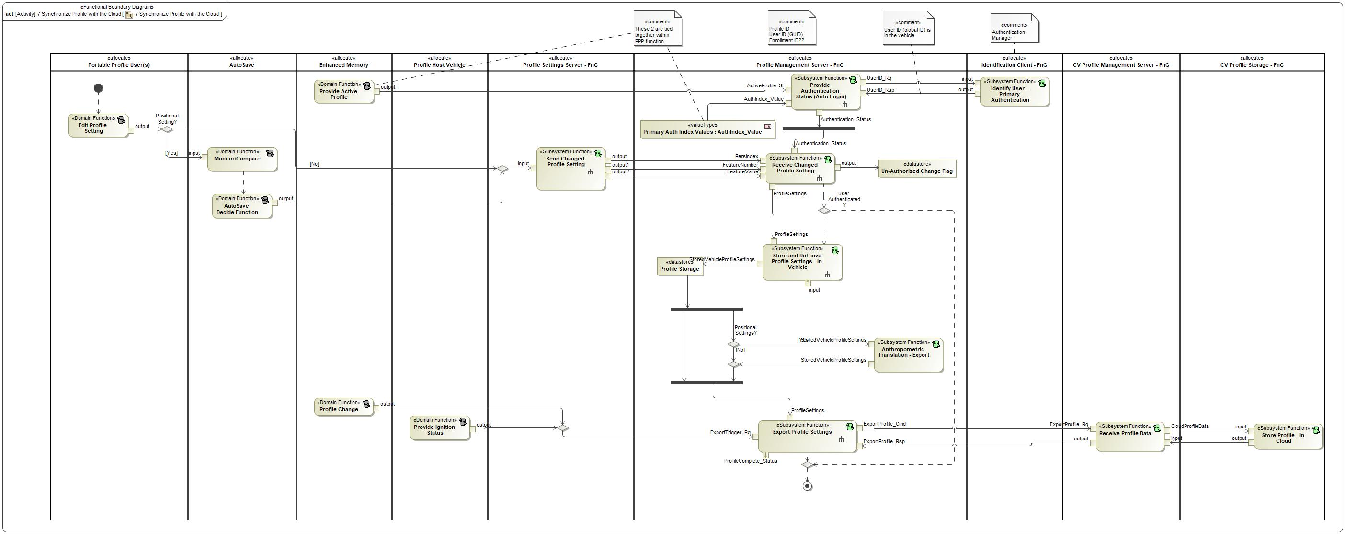

Figure : Activity Diagram of 168958035.jpg “7 Synchronize Profile with the Cloud” calling 1201103667.jpg “Send Changed Profile Setting”

### Function Interfaces

#### Logical Inputs

|  |  |
| --- | --- |
| **Signal Name** | **Description** |
| input  Signal:  2136721000.jpg Setting Changed | Received from:   * 130315544.jpg Edit Profile Setting * 130315544.jpg AutoSave Decide Function |

#### Logical Outputs

|  |  |
| --- | --- |
| **Signal Name** | **Description** |
| output2  Type:  1645473355.jpg FeatureValue | Signal Description:  Carries the setting configuration for a Feature Number. Feature Numbers and Feature Values are always paired together.  Sent to:   * 1201103667.jpg Receive Changed Profile Setting |
| output  Type:  1645473355.jpg PersIndex | Signal Description:  Determines the profile number that the Profile Setting Server needs to execute an operation on.  Sent to:   * 1201103667.jpg Receive Changed Profile Setting |
| output1  Type:  1645473355.jpg FeatureNumber | Signal Description:  Signal that carries the hexadecimal values assigned to each setting that is stored in the profile.  Sent to:   * 1201103667.jpg Receive Changed Profile Setting |

#### Logical Parameters

*Not supported by MagicDraw report generation.*

### Function Modeling

#### Use Cases

*Not supported by MagicDraw report generation.*

#### State Charts / Activity Diagrams / Sequence Diagrams / Decision Tables

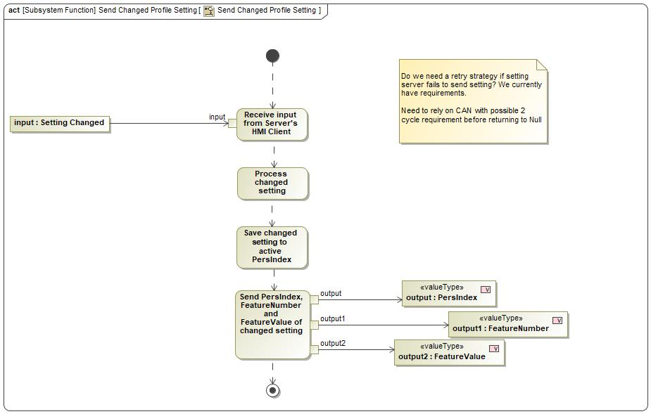

Figure : Send Changed Profile Setting

### Function Requirements

#### Functional Requirements

##### Normal Operation

REQ-352224/A Send ReturnProfileSetting upon setting change

When a customer makes a change to a profile setting, the Profile Setting Servers shall send a ReturnProfileSetting message with active PersIndex, FeatureNumber and changed FeatureValue to the Profile Management Server.

|  |  |  |  |  |  |  |  |
| --- | --- | --- | --- | --- | --- | --- | --- |
| Requirement ID: REQ-352224/A | | | | | | | |
| **Rationale** |  | | | | | | |
| **Acceptance Criteria** |  | | | | | | |
| **Notes** |  | | | | | | |
| **Source** |  | | | | | **Owner** |  |
| **Source Req.** |  | | | | | **V&V Method** |  |
| **Type** |  | | | **Priority** |  | **Status** |  |
| [Req. Template](http://wiki.ford.com/display/RequirementsEngineering/Requirements+Attributes) Version | | 6.0 | End of Requirement | | | | |

REQ-405869/A Powermode conditions to send ReturnProfileSetting message

Each Profile Setting Server shall be able to send the ReturnProfileSetting message to the Profile Management Server whenever the customer is able to change a setting using the Profile Setting Server's HMI Client.

|  |  |  |  |  |  |  |  |
| --- | --- | --- | --- | --- | --- | --- | --- |
| Requirement ID: REQ-405869/A | | | | | | | |
| **Rationale** | Whenever a customer can make a change to a profile setting, the profile setting server should send the changed value to the profile management server. | | | | | | |
| **Acceptance Criteria** |  | | | | | | |
| **Notes** |  | | | | | | |
| **Source** |  | | | | | **Owner** |  |
| **Source Req.** |  | | | | | **V&V Method** |  |
| **Type** |  | | | **Priority** |  | **Status** |  |
| [Req. Template](http://wiki.ford.com/display/RequirementsEngineering/Requirements+Attributes) Version | | 6.0 | End of Requirement | | | | |

REQ-405871/A Auto-Saved positional settings

When a positional setting has been determined to be auto-saved by the Auto Save feature, the Profile Setting Server shall send the updated positional settings to the Profile Management Server using the ReturnProfileSetting messagel.

|  |  |  |  |  |  |  |  |
| --- | --- | --- | --- | --- | --- | --- | --- |
| Requirement ID: REQ-405871/A | | | | | | | |
| **Rationale** |  | | | | | | |
| **Acceptance Criteria** |  | | | | | | |
| **Notes** |  | | | | | | |
| **Source** |  | | | | | **Owner** |  |
| **Source Req.** |  | | | | | **V&V Method** |  |
| **Type** |  | | | **Priority** |  | **Status** |  |
| [Req. Template](http://wiki.ford.com/display/RequirementsEngineering/Requirements+Attributes) Version | | 6.0 | End of Requirement | | | | |

##### Error Handling

REQ-405870/A Unable to send changed profile setting

If the Profile Setting Server is unable to send a changed profile setting to the Profile Management Server, the Profile Setting Server shall attempt to retry sending the ReturnProfileSetting for the affected setting. The amount of retries is defined by the configurable parameter Retry_Count_PSS.

|  |  |  |  |  |  |  |  |
| --- | --- | --- | --- | --- | --- | --- | --- |
| Requirement ID: REQ-405870/A | | | | | | | |
| **Rationale** |  | | | | | | |
| **Acceptance Criteria** |  | | | | | | |
| **Notes** |  | | | | | | |
| **Source** |  | | | | | **Owner** |  |
| **Source Req.** |  | | | | | **V&V Method** |  |
| **Type** |  | | | **Priority** |  | **Status** |  |
| [Req. Template](http://wiki.ford.com/display/RequirementsEngineering/Requirements+Attributes) Version | | 6.0 | End of Requirement | | | | |

REQ-405873/A Failed to send changed value after retries

If the Profile Setting Server reaches the Retry_Count_PSS maximum and has still not successfully sent the ReturnProfileSetting to the Profile Management Server, the Profile Setting Server shall send an error code to the Profile Management Server indicating a failure.

|  |  |  |  |  |  |  |  |
| --- | --- | --- | --- | --- | --- | --- | --- |
| Requirement ID: REQ-405873/A | | | | | | | |
| **Rationale** |  | | | | | | |
| **Acceptance Criteria** |  | | | | | | |
| **Notes** |  | | | | | | |
| **Source** |  | | | | | **Owner** |  |
| **Source Req.** |  | | | | | **V&V Method** |  |
| **Type** |  | | | **Priority** |  | **Status** |  |
| [Req. Template](http://wiki.ford.com/display/RequirementsEngineering/Requirements+Attributes) Version | | 6.0 | End of Requirement | | | | |

#### Non-Functional Requirements

REQ-352240/A Response to setting change performance

After a setting is changed, the Profile Setting Servers shall send the PPPSetting_Rsp message to the Profile Management Server within XX ms of the setting being changed.

|  |  |  |  |  |  |  |  |
| --- | --- | --- | --- | --- | --- | --- | --- |
| Requirement ID: REQ-352240/A | | | | | | | |
| **Rationale** |  | | | | | | |
| **Acceptance Criteria** |  | | | | | | |
| **Notes** |  | | | | | | |
| **Source** |  | | | | | **Owner** |  |
| **Source Req.** |  | | | | | **V&V Method** |  |
| **Type** | Non-Functional | | | **Priority** |  | **Status** |  |
| [Req. Template](http://wiki.ford.com/display/RequirementsEngineering/Requirements+Attributes) Version | | 6.0 | End of Requirement | | | | |

REQ-405872/A Retry_Count_PSS

Each Profile Setting Server shall implement the configurable parameter Retry_Count_PSS that defines how many times the Profile Setting Server attempts to send the ChangedSetting_Value after a failure.

Retry_Count_PSS default = 5.

|  |  |  |  |  |  |  |  |
| --- | --- | --- | --- | --- | --- | --- | --- |
| Requirement ID: REQ-405872/A | | | | | | | |
| **Rationale** |  | | | | | | |
| **Acceptance Criteria** |  | | | | | | |
| **Notes** |  | | | | | | |
| **Source** |  | | | | | **Owner** |  |
| **Source Req.** |  | | | | | **V&V Method** |  |
| **Type** |  | | | **Priority** |  | **Status** |  |
| [Req. Template](http://wiki.ford.com/display/RequirementsEngineering/Requirements+Attributes) Version | | 6.0 | End of Requirement | | | | |

#### Functional Safety Requirements

No Functional Safety Requirements specified.

##### ASIL Decomposition of Functional Safety Requirements

No Functional Safety Requirements with ASIL Decompositions specified.

#### Other Requirements

##### Design Requirements

No Design Requirements specified.

# Open Concerns

**#Hint:** The following list presents open concerns, which have to be discussed or clarified over the course of the on-going requirements engineering.

| ID | Concern Description | e-Tracker / Reference | Responsible | Status | Solution |
| --- | --- | --- | --- | --- | --- |
| 1 |  |  |  |  |  |

Table 8: Open Concerns *(Not supported by MagicDraw report generation.)*

# Revision History

**#Hint:** A new version number is assigned to a document with a given revision each time it is checked in to Team Center (TCSE). After release of a revision, the document cannot be edited and no new versions can be created on that revision. When updating the document after that, a new revision has to be created and new versions on that revision will be created upon checking in.

No Revision History found.

## Template Revisions

*#Important: Do not change this section*

|  |  |  |  |  |
| --- | --- | --- | --- | --- |
| Version | Rev. | Date | Description | Responsible |
| *1* | *0* | *2016-02-26* | *Initial version, derived from FDS* | *Jbaden1* |
| *1* | *1* | *2016-02-26* | *Word properties corrected* | *Jbaden1* |
| *1* | *2* | *2016-03-10* | *Clean up of document meta data (Word properties)* | *Jbaden1* |
| *1* | *3* | *2016-03-22* | * *Footer formatting corrected (Issue 19)* * *“Constraints” chapter renamed to “Input Requirements” (Issue 20)* | *Jbaden1* |
| *1* | *4* | *2016-04-20* | * *Broken Wiki links repaired* | *Jbaden1* |
| *2* | *0* | *2016-06-10* | * *Document metadata adapted. Prepared for new macros* * *DTC table removed* * *HMI function added as a chapter (details still to be refined)* * *Signal / Parameter IDs column deleted interface tables* | *Jbaden1* |
| *2* | *1* | *2016-07-14* | * *Converted to SysML diagrams* * *HMI section further elaborated* * *Template version added to footer* * *Dedicated Startup / Shutdown sections removed (only hints added)* * *Data Dictionary reworked and Signal / Parameter IDs column re-introduced* | *Jbaden1* |
| *2* | *2* | *2016-12-07* | * *Minor formatting changes* | *Jbaden1* |
| *3* |  |  | *Skipped to synchronize with Specification_Macros.dotm* |  |
| *4* |  |
| *5* | *0* | *2017-01-13* | * *Meta data updated for specification macros, version 3.1* * *SW Unit chapter removed for the time being* * *Green boxes added for user hints* | *Jbaden1* |
| *5* | *1* | *2017-01-18* | * *Some additional hints.* * *Hyperlinks highlighted in hints* | *Jbaden1* |
| *6* | *0* | *2017-04-28* | * *Editorial change. Hints added to chapter 4.1.4* * *Chapter “Traceability Matrix” removed* | *Jbaden1* |
| *6* | *0* | *2018-04-28* | * *CR69/63: New chapters added for Functional Safety (FTTI and Technical Safety Requirements)* * *CR53: New coversheet + additional meta-data* * *CR76: merge sections for configuration and for calibration parameters into one on Function Level* | *Jbaden1* |
| *6* | *0* | *2018-08-06* | * *CR66: Fix version numbering in footer of Function Spec* | *Jbaden1* |
| *6* | *0* | *2018-09-28* | * *Broken links to RE Wiki repaired* | *Jbaden1* |
| *6* | *0* | *2018-10-31* | * *Minor corrections on cover sheet and in footer to be more GIS compliant and VSEM aligned* * *“Overview” and “Description” exchanged in headings (following common sense)* | *Jbaden1* |
| *6* | *0* | *2018-11-12* | * *Explanatory text in Variants” section revised* * *Functional Safety modifications as agreed with FuSa core team (Baseline: November 2018 Dearborn On-Site)* | *Jbaden1* |
| *M* |  | *2019-04-02* | * *Initial version of SysML report template* | *snuesch* |
| *M* |  | *2019-04-05* | * *Improved dialog boxes to select function group* | *snuesch* |
| *M* |  | *2019-04-26* | * *Improved function interfaces (support of additional elements (e.g., send signal action, add structural feature action, merge node, decision node, activity parameter nodes, etc.) and pins)* | *snuesch* |
| *N* |  | *2019-08-19* | * *For each function now also requirements satisfied by activity parameter nodes and function outputs are populated.* | *snuesch* |
| *N* |  | *2019-08-21* | * *Improved glossary and acronym tables* | *snuesch* |
| *N* |  | *2019-09-20* | * *Updated Function Interfaces tables with better wording. Added a report template variable that allows to disable senders and receivers. Sorted requirements by ID.* | *snuesch* |
| *N* |  | *2019-09-27* | * *Green hints now only show up for first function.* * *labelTag variable can be used to filter revision history.* | *snuesch* |

# Appendix

## Data Dictionary

### Logical Signals

**#Macro:** [Add Ins -> Add Requirement macro](http://wiki.ford.com/display/RequirementsEngineering/Adding+a+Logical+Signal+or+Parameter) (select “Logical Signal” as type)

ApplySettingStatus

Determines if a profile setting had successfully been set by the Profile Setting Server.

|  |  |  |
| --- | --- | --- |
| **ASIL** | | QM |
| **Encoding Type Name** | | Discrete |
| Note: An encoding is either discrete or continuous. Delete fields below which are not needed | | |
| **Value**  (Discrete  Encoding) | 0x0 | Final Result – Success |
| 0x1 | Final Result – Fail |
| 0x2 | Final Result – Information |
| 0x3 | Intermediate Result - Wait |
| **Unit** | |  |

FeatureNumber

Signal that carries the hexadecimal values assigned to each setting that is stored in the profile.

|  |  |  |
| --- | --- | --- |
| **ASIL** | | QM |
| **Encoding Type Name** | | Continuous |
| Note: An encoding is either discrete or continuous. Delete fields below which are not needed | | |
| **Value**  (Continuous Encoding) | Min Value | 0x0000 |
| Max Value | 0xFFFF |
| Resolution | 0x1 |
| Offset | None |
| **Unit** | |  |

FeatureValue

Carries the setting configuration for a Feature Number. Feature Numbers and Feature Values are always paired together.

|  |  |  |
| --- | --- | --- |
| **ASIL** | | QM |
| **Encoding Type Name** | | Continuous |
| Note: An encoding is either discrete or continuous. Delete fields below which are not needed | | |
| **Value**  (Continuous Encoding) | Min Value | 0x0000 |
| Max Value | 0xFFFF |
| Resolution | 0x1 |
| Offset | None |
| **Unit** | |  |

OperationCode

Determines which operation the Profile Setting Server is requested to execute. Depending on the operation code, the following signals could contain more or less data.

|  |  |  |
| --- | --- | --- |
| **ASIL** | | QM |
| **Encoding Type Name** | | Discrete |
| Note: An encoding is either discrete or continuous. Delete fields below which are not needed | | |
| **Value**  (Discrete  Encoding) | 0x00 | Reserved |
| 0x01 | Query |
| 0x02 | Set |
| 0x03 | Import |
| 0x04 | Export |
| 0x05 | Copy |
| 0x06 – 0xFF | Reserved |
| **Unit** | |  |

PersIndex

Determines the profile number that the Profile Setting Server needs to execute an operation on.

|  |  |  |
| --- | --- | --- |
| **ASIL** | | QM |
| **Encoding Type Name** | | Discrete |
| Note: An encoding is either discrete or continuous. Delete fields below which are not needed | | |
| **Value**  (Discrete  Encoding) | 0x00 | Pers1 |
| 0x01 | Pers2 |
| 0x02 | Pers3 |
| 0x03 | Pers4 |
| 0x04 | Vehicle |
| 0x05 – 0xFF | Reserved |
| **Unit** | |  |

### Logical Parameters

**#Macro:** [Add Ins -> Add Requirement macro](http://wiki.ford.com/display/RequirementsEngineering/Adding+a+Logical+Signal+or+Parameter) (select “Logical Parameter” as type)

### Encoding Types

**#Macro:** [Add Ins -> Add Requirement macro](http://wiki.ford.com/display/RequirementsEngineering/Adding+an+Encoding+Type) (select “Encoding Type” as type)

## Glossary

**#Hint**: Terms, concepts and abbreviations used in the document shall be defined and illustrated here. Note that changes to terms and/or concepts described in this section tend to cause major updates to this document.

The tables below have feature specific definitions and abbreviations. For additional, non-feature specific terms please refer to the [RE Glossary](http://wiki.ford.com/display/RequirementsEngineering/Glossary?src=contextnavpagetreemode)

### Definitions

**#Hint:** The table below has definitions and abbreviations relevant for the functions in this document. For additional terms please refer to the [RE Glossary](http://wiki.ford.com/display/RequirementsEngineering/Glossary?src=contextnavpagetreemode)

| **Definition** | **Description** |
| --- | --- |
| Feature Number | A hexadecimal value assigned to a profile setting. This was established by the Feature Based Message Protocol (FBMP) and is used by PPP to create a common understanding of what the profile settings are between vehicles. |
| Feature Value | Determine the status of the active setting. For example, Easy Entry/Exit can be configured ON or OFF or a profile, the feature value can be either ON 0x01 or OFF 0x00. |
| FTTI | Fault Tolerance Time Interval |
| HMI Client | The technology used to display a profile setting's current status to the user. Example, radio stations are displayed to the customer using the SYNC screen as an HMI client, but the stations are stored in the Audio Head Unit. |
| Pers Index | The index number provided to a profile in the vehicle. This helps determine which profile is activated throughout the vehicle. |
| PPP | Personal and Portable Profiles |
| Profile Setting Servers | The Profile Setting Server logical block is a generic term for any vehicle module that owns the execution and storage of profile settings. |
| Profile Settings | All user configurable settings in the vehicle that can be added to the user's profile. Examples include radio stations, ADAS settings, Ambient Light, etc. |

Table 9: Definitions used in this document

### Abbreviations

No acronyms specified.

Document ends here.